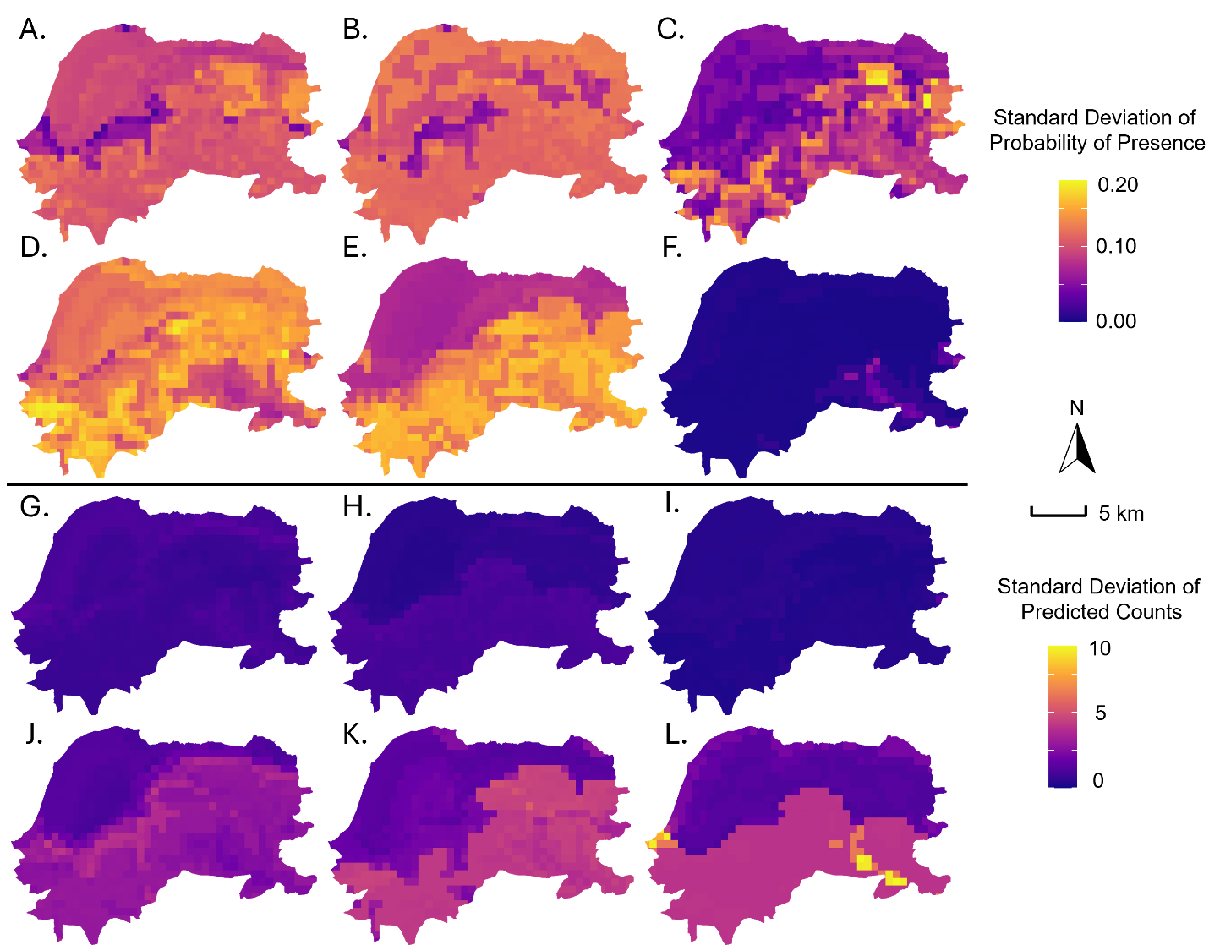
Supplemental Figure 2. Uncertainty in habitat suitability and abundance predictions for six mosquito species across Haiti. Standard deviation of predicted probability of presence (A-F) and predicted mosquito abundance (G-L) from 100 bootstrap model replicates for: (A, G) Aedes aegypti, (B, H) Aedes albopictus, (C, I) Aedes mediovittatus, (D, J) Culex quinquefasciatus, (E, K) Culex nigripalpus, and (F, L) Psorophora columbiae. Higher values indicate greater uncertainty in model predictions.
Alternative Text: Multi-panel map showing prediction uncertainty across Haiti for six mosquito species. Top two rows show standard deviation of presence probability (yellow-orange-purple gradient, 0.00-0.20 scale) for panels A-F. Bottom two rows show standard deviation of abundance predictions (yellow-orange-purple gradient, 0-10 scale) for panels G-L. Species coverage varies, with Cx. quinquefasciatus and Cx. nigripalpus showing highest presence uncertainty (panels D-E), while Ps. columbiae shows lowest overall uncertainty (panels F, L).

